Eighth International Conference on Futuristic Trends in Networks and Computing Technologies (FTNCT08) held at
Ghaziabad, UP, India

Comparative Deep Neural Study For Stage-Wise Alzheimer’s Disease Detection Using Brain MRI
Shashank Shetgeriª , Srushti Honnangiª , Anushri Kajagarª , Tanvi Korgaonkarª ,
Salma Shahapurª , Rajashri Khanaiª , Niranjan Muchandiª
ªDepartment of Computer Science and Engineering, KLE Technological University Dr. M. S. Sheshgiri Campus, Belagavi 590008, Karnataka, India
Abstract
Alzheimer’s disease frequently impacts older adults and among the leading disorders associated with aging and brain functions.Since it is highly prevalent, correctly identifying Alzheimer’s Disease is crucial for initiating treatment early,which leads to best outcomes. With the advancement of deep learning algorithms, it is useful to analyze and compare various architectures of CNNs and their ability to distinguish stages of AD. Models such as ResNet50, VGG16, and DenseNet201, as well as InceptionV3, EfficientNet-B1, and a custom CNN, were tested to classify MRIs of Alzheimer's Disease patients. The architecture were ADNIs' subset and separated into four classes: Mild Dementia, Moderate Dementia, Very Mild Dementia, and Non Demented. The architecture trained on the dataset showed that modern architectures perform best when compared to older ones.
Keywords:AD Neuroimaging Initiative(ADNI) ; EfficientNet-B1 ; DenseNet201 ; Early Diagnosis ; Resnet ; VGG16 ; InceptionV3 ; Multi-Class Classification;
1. Introduction
Alzheimer’s disease(AD) is a condition that affects the brain’s ability to function normally.It is a disorder which leads to the deterioration of cognitive skills such as memory, language, reasoning, and behavior, significantly impairing daily functioning and eventually impacting the quality of life for persons affected.Individuals typically diagnosed with this condition are generally 65 years old or older.Extensive Education is linked to increased development of synapses within the brain.This buildup of synaptic reserves allow those affected to better adapt as neural cells are lost during the advance of the disease [3].
The rate of AD diagnosis continues to increase with global life expectancy, presenting a challenge to health care systems and caregivers alike. The ability to recognize AD, and the myriad of clinical stages that it presents in, remains essential for early intervention, supporting patient care, and for future research treatments.Many methods now apply biomarkers 3D MRI scans to identify patient conditions and predict future results.Beyond AD ,techniques like MRI,PET scans are often used to monitor the brain and aid in diagnosing Alzheimer’s disease.MRI serves as an essential technique for identifying changes in brain anatomy and activity linked to disease.It is considered a key approach for recognizing initial stages of AD,with the advantage of being non-invasive and usable for repeated patient assessments without surgery[5]. Furthermore, advanced deep learning-part of artificial intelligence has revolutionized how medical images are interpreted,making analysis of visual data precise and efficient [6].
2. Related Work
Y. Chen et al. applied deep learning to MRI for multiclass Alzheimer’s staging, achieving up to 99% accuracy; further external validation is needed[1]. E.R. Vinukonda et al. proposed a hybrid network (DeepLabV3+ & ResNext) yielding 98% accuracy; performance limited by class imbalance[2]. A.D. Arya et al. reviewed ML/DL approaches, finding multimodal (MRI+PET) methods outperform MRI alone and recommending cross-cohort evaluation[3]. Shaji et al., Helaly et al. showed CNN and transfer learning models achieved 69–97% accuracy for dementia classification, affected by small sample sizes[4]. S.E. Sorour , compared deep learning architectures for detection of early Alzheimer’s in MRI, calling for clearer reporting of experimental details[5]. Fundación Dialenti et al. emphasized combining imaging and biomarkers for classification, with a need for larger, standardized datasets[6]. S. Pan, S. Wang, X. Jin, S. Lu, et al. introduced a multistage MRI-based framework with up to 93.93% accuracy; overfitting and single-site data noted[7]. R. Turrisi et al. reported CNNs reaching 87% validation and 82% test accuracy; larger and more diverse datasets may improve results[8].El-Assy et al. developed a custom Convolutional neural network for AD detection (85–95% accuracy); recommended addressing class imbalance for further gains[9]. B.S. Rao et al. assessed various deep learning models for MRI-based AD classification; highlighted the importance of MRI quality and external evaluation[10].

3. Methodology
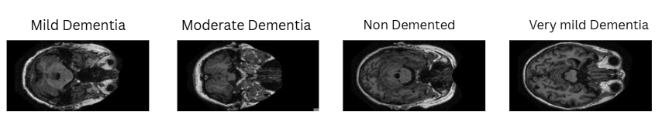
Fig 1.(a)Mild-Dementia; (b)Moderate-Dementia; (c)Non-Dementia; (d)Very Mild Dementia.

Fig.1 dataset consists of MRI brain data images divided into 4 groups:Mild-Dementia, Moderate-Dementia,Non-Dementia and Very Mild-Dementia corresponding figures are shown respectively. These categories represent increasing levels of cognitive decline, offering a comprehensive range of samples for training and testing. Each image corresponds to a brain scale slice in grayscale format. The dataset was curated to remove duplicates, corrupted files, and misabled images. To ensure consistency, all images were organized into structured directories, one for each dementia stage. This made it easy for loading and labeling through automated scripts in Python.

3.1 DataSet Collection

Table 1 presents the quantity of MRI scans in each diagnostic class before and after dataset balancing.Originally, the dataset showed strong class imbalance,with non-denmented images significantly outnumbering others.After balancing,each class was adjusted to contain a more comparable image count to support fair and effective model training.

Table 1. Dataset Description
Class | Number of Images (Original) | Number of Images (After Balancing)
Non-Dementia | 67,222 | 40,000
Mild-Dementia | 5,002 | 10,000
Moderate-Dementia | 488 | 8000
Very Mild-Dementia | 13,725 | 20,000
The datafile was partitioned into training , validation and testing sets using stratified sampling maintaining class balance across all subsets to avoid bias in model learning.The split ratio of 70% for training,15% for testing and 15% for validation was implemented.
3.2 Models Description
Deep learning, a form of artificial intelligence, has assisted doctors in improving ways to diagnose Alzheimer's disease from brain scans.The research investigated multiple DL architectures to bifurcate between different stages of Alzheimer,s disease by analyzing MRI scans.Table 2 presents descriptions of different models used while training and testing which includes their type ,purpose and key advantages.
Table 2.Model Description
Model Name | Model Type | Description | Key Strengths/Focus
CNN (Custom) | CNN | A straightforward neural network built from scratch for image classification, using stacked layers. | Fast to train, simple, good as baseline.
ResNet50 | Deep-learning CNN | Uses skip (residual) connections, allowing very deep networks without losing important signals. | Handles deeper layers; less overfitting.
VGG16 | Deep-learning CNN | Stacks many convolutional layers in a simple pattern for strong feature extraction. | Easy to use, proven for image tasks.
DenseNet201 | Deep-learning CNN | Connects each layer to every other, so features are reused and learning is more efficient. | Very efficient learning, robust results.
InceptionV3 | Deep-learning CNN | Combines different filter sizes at every level for multi-scale feature extraction. | Captures diverse image patterns well.
EfficientNet-B1 | Deep-learning CNN | Scales width, depth, and resolution together so the network is both accurate and efficient. | Cutting-edge accuracy, lightweight.

3.3 Model WorkFlow 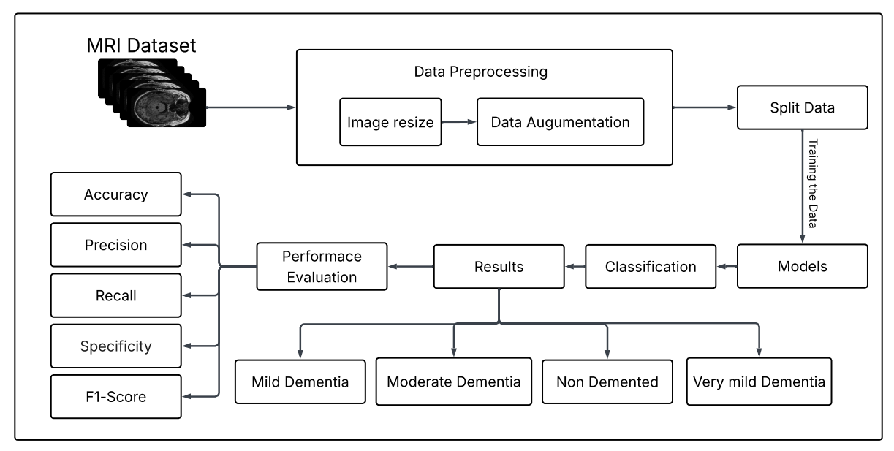
Fig 2.MRI-based demented classification workflow.
Fig.2 illustrates the overall workflow for classifying AD stages using deep learning on MRI data. The study focuses on classifying AD stages ,starting with essential data preprocessing including data resizing and data augmentation to enhance the quality and diversity of input images. The data file was partitioned into model learning , verification and evaluation sets before working on various neural network models. These models are trained to classify the images into four categories. The outcomes are organized as classification results, which is evaluated using evaluation metrics. This structured pipeline ensures that each step from data preparation to final model evaluation is clearly defined, resulting in reliable outcomes for dementia classification.
3.4 Image Loading
Where possible, all MRI image files were imported into the programming environment through pre-written automated scripting provisions using multiple computer science innovations in Python, including OpenCV, NumPy, and Pandas. Because of the hierarchical structure of the dataset, images ended up being automatically classified by class, or dementia diagnosis, as the folder names or metadata of each image reflected the associated label. Thus, each image automatically gained a class designation corresponding to diagnosis, creating a reality where image data and diagnosis had a consistent, reproducible means of access for any further transformation or implementation during model training.
3.5 Image Resizing
Table 3 summarizes the image details for each model used in this study.All MRI images were resized to a consistent shape to ensure compatibility with each neural network architecture. However, the target image size varied by model, according to the requirements of each backbone, filter sizes, and pooling arrangements. Resizing ensures that the input format is correct, which prevents errors during training and ensures that learned features are consistent.

Table 3. Model-Specific Image Resizing Parameters.
Models | Resizing Details
EfficientNet-B1 | Images resized to either 240 ×240 pixels, matching EfficientNet’s native input resolution for optimal performance.
ResNet50,VGG16,  DenseNet201 | Images were adjusted to 224 × 224 pixels to meet the input specifications of pretrained neural network models.
InceptionV3 | Images resized to 240 ×240pixels as required for InceptionV3’s architecture.
Custom CNN | Images resized to either 128 ×128 as per the custom implementation to improve speed and suit model design.

3.6 Normalization and Data Augmentation

All Images are first resized to 128 x 128 so the Model receives a fixed-size input. The ToTesor() Operation automatically normalizes pixel values by converting them from the 0 - 255 range to 0 - 1, which prepares the data for scale gradient updates during training. In the training pipeline, an additional step RandomHorizontalFlip() is applied, which randomly flips images left-right to increase the variation in the dataset. This helps the model avoid overfitting by exposing it to multiple orientations of MRI scans.

3.7 Model Implementation

The implementation of a Custom Convolution Neural Network(CNN) contains two major components: convolution feature extraction is fully connected classification. The model first processes the MRI images through multiple convolution layers, each followed by ReLU activation and maxpooling. These layers progressively learn spatial patterns such as edges, texture, and structure differences found in MRI scans. The output from the final convolution block is converted into a 1-D array and subsequently processed into fully connected layers that perform high-level reasoning and classify the MRI into its respective category .The forward pass processes the input through all the convolution layers .Then, through the dense layer, and finally return the predicted class scores.

3.8 Evaluation Metric

ReLU Activation
ReLU (x) = max ( 0, x ) (1)
Eq(1) adds non-linearity to the model.Used throughout VGG, ResNet , EfficientNet , CNN

Average Pooling
O(i,j) = 1khkw I ( i+m , j+n) (2)
Eq(2) computes the average value within each window for dimensionality reduction where
kw is kernel width and kh is kernel height.

Max Pooling
O(i,j) = max window I(i+m , j+n) (3)
Eq(3) selects the maximum value within each window to reduce spatial dimensions.

Flatten Layer
Flatten(H$×$W$×$C)=HWC vector (4)
Eq(4) converts multi-dimentional input into a single vector for fully connected layers where
H is height , C is channel , W is width.

Fully Connected Layers
y=Wx+b (5)
Eq(5) applies a linear transformation to input features, W represents weight bias,x represents
input and B represents bias.

Batch Normalization
Normalize:
$\hat{x}$ = $\frac{x - μ}{\sqrt{σ^{2}+ϵ}}$ (6)
Then scale + shift :
y= $γ\hat{x }+β$
Parameters Learned by model where $γ$is scale and $β$is shift
Eq(6) normalizes inputs for each batch and applies learned scaling and shifting.

3.9 Training & Evaluation

Stratified training and validation sets were generated for appropriate model classification of a balanced approach. Models were fitted with Adam optimizers and relatively equivalent learning rates and loss functions adjusted for multiclass classification for training. Early stopping is deployed relative to val_loss and val_accuracy for overfitting prevention and automatic model checkpoint saving kept the best performing.Table 4 lists the main training parameters used for each model.

Table 4.Parameters for Training.
Model | Optimizer | Learning  Rate | Loss Function | Early  Stopping | Check  point | Batch Size | Epochs
Custom  CNN | Adam | 0.001 | SparseCategorical  Crossentropy | Yes | Yes | 32 | 10
Efficient  Net-B1 | Adam | 0.0001 | CrossEntropyLoss | Yes | Yes | 32 | 20
ResNet50 | Adam | 0.0001 | Categorical  Crossentropy | Yes | Yes | 32 | 50
VGG16 | Adam | 0.0001 | Categorical  Crossentropy | Yes | Yes | 32 | 10
DenseNet201 | Adam | 0.0001 | CategoricalCross  entropy or similar | Yes | Yes | 32 | 10–15
InceptionV3 | Adam | 0.0001 | CrossEntropyLoss | Yes | Yes | 32 | 30

4. Results

This work has implemented and evaluated the performance of six CNN architectures: Custom CNN, VGG16, ResNet50, DenseNet201, InceptionV3, and EfficientNet-B1, for various stages of AD using MRI scans from the ADNI database.Table 5 summarizes the accuracy ,macro and weighted precision,recall, F1-score and test sample counts for each deep learning model, allowing comparison of their classification performance.

Key results included:
Custom CNN, DenseNet201, ResNet50, and VGG16 had the highest overall accuracy, consistently exceeding 95% accuracy when distinguishing between various stages of AD. These models demonstrated great ability in learning detailed and subtle features from MRI data. EfficientNet-B1 and InceptionV3 also performed well, having slightly lower accuracy rates than DenseNet201 and ResNet50, but still turning in a good overall performance.

The following abbreviations are used in the results table:
- Acc = Final Test set accuracy
- Pre(M) = Precision averaged equally across all classes(macro precision)
- Reca(M)= Recall averaged equally across all classes(macro recall)
- F1(W)= F1 score calculated as the unweighted average across all classes(macro F1 score)
- Pre(W) , Reca(W) , F1(W)=Weighted precision , recall and F1-score respectively
- Number=Number of test samples evaluated for each model
Table 5 . Summary of Test Metrics for All Deep Learning Models.
Model | Acc | Pre (M) | Reca (M) | F1(M) | Pre(W) | Reca(W) | F1(W) | Number
CNN | 0.98 | 0.98 | 0.98 | 0.98 | 0.98 | 0.98 | 0.98 | 15600
DenseNet201 | 0.98 | 0.98 | 0.98 | 0.98 | 0.98 | 0.98 | 0.98 | 160
EffNet-B1 | 0.75 | 0.69 | 0.75 | 0.71 | 0.76 | 0.75 | 0.75 | 15600
VGG16 | 0.98 | 0.97 | 0.98 | 0.97 | 0.98 | 0.98 | 0.98 | 15600
InceptV3 | 0.75 | 0.43 | 0.29 | 0.29 | 0.72 | 0.79 | 0.72 | 15600
ResNet50 | 0.95 | 0.87 | 0.89 | 0.88 | 0.92 | 0.91 | 0.91 | 15600
As per the results, the Models such as Custom CNN, VGG16 and Densenet201 showed best performance, achieving substantial high accuracy, sensitivity, specificity, and F1-score whereas the models like EffNet-B1 and InceptV3 showed poor Performance.
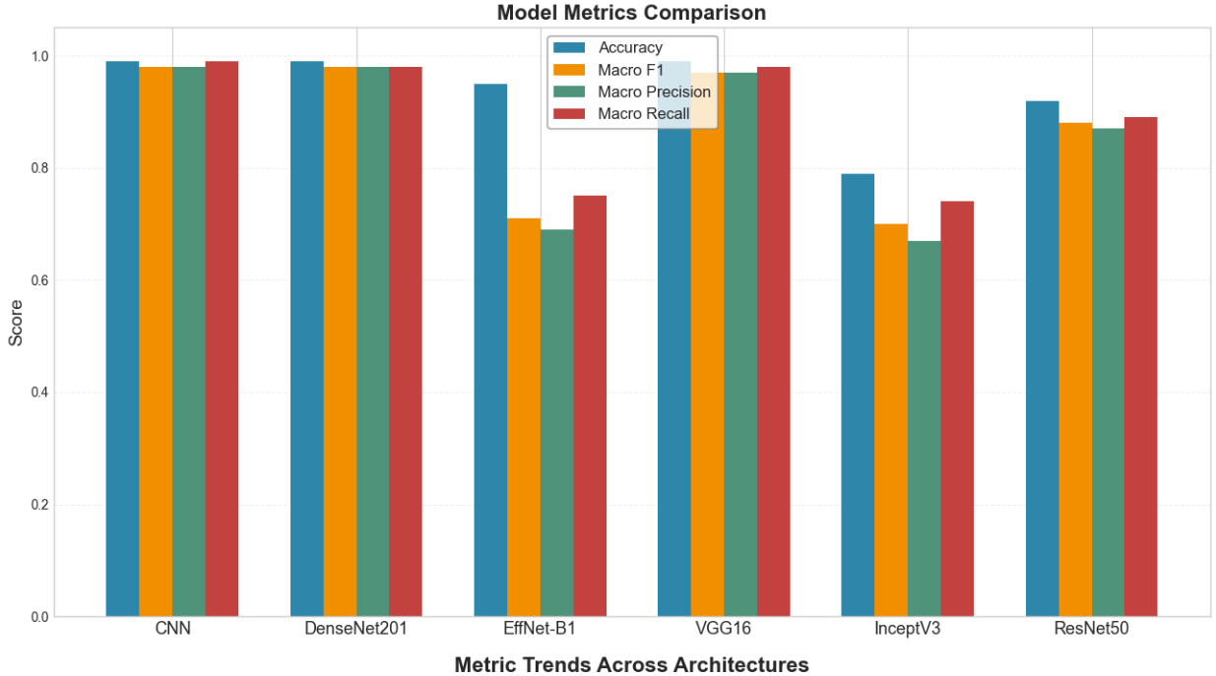
Fig 3.Model Metrics Comparision

Fig.3 is a comparison of the performance of various deep-learning architectures in terms of their key evaluation metrics.Models such as CNN, DenseNet201, and VGG16 have exhibited high and stable scores for accuracy , Macro F1 , precision, and recall , thereby implying that these models have not only correctly classified the majority of the samples but have also treated all the classes quite fairly.Efficient-B1 and InceptionV3, on the other hand,are at a considerable distance from the rest , thus pointing to a greater struggle with balanced classification.ResNet50 is a middle-ground performer as it is more stable than the weaker models but it is still a bit behind the top performers.

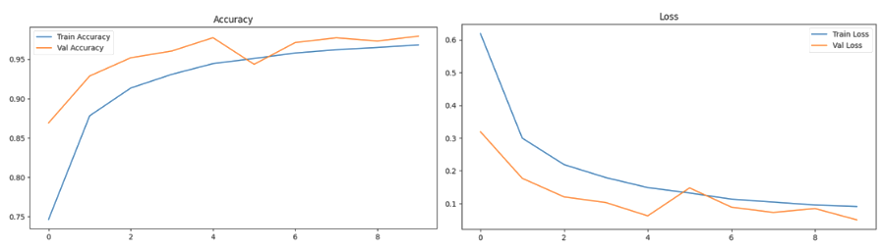
Fig 4.Performance of CNN model (a)Accuracy Curve; (b)Loss Curve.
Fig.4 represents the accuracy and loss curves for CNN model’s performance.Fig.4(a) shows training and validation accuracy curves across various batches(epoches).Two lines start lower and rise sharply in the initial epochs, with validation accuracy closely matching or exceeding training accuracy from early on.This parallel rise shows rapid learning and strong generalization .In Fig.4(b) both training and validation loss curves decrease consistently,approaching low values by the final epochs.The similar trends and tight proximity of the lines suggest minimal overfitting,verifies that the model is successfully capturing messaging patterns from the data rather than overfitting to random noise.Such patterns reflect stable and reliable learning dynamics in Custom CNN.
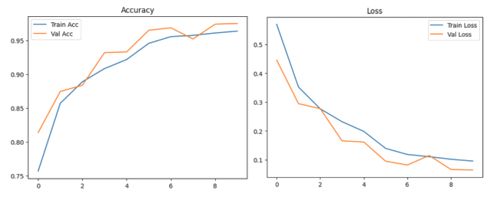Fig 5. Performance of VGG16 Model (a)Accuracy Curve; (b)Loss Curve.
Fig.5 represents the accuracy and loss curves for VGG16 model’s performance.Fig.5(a) both training and validation accuracy improve over successive epochs,from the validation curve generally mirroring the training curve’s trajectory and reaching high values by end.This steady and synchronized increase signifies effective generalization to unseen data.Fig.5(b) illustrates that both training and validation loss decrease smoothly throughout,with classes remaining closely matched across epochs.Such consistent downward movement and tight alignment between the curves indicate that the VGG16 model learns effectively while avoiding significant overfitting.
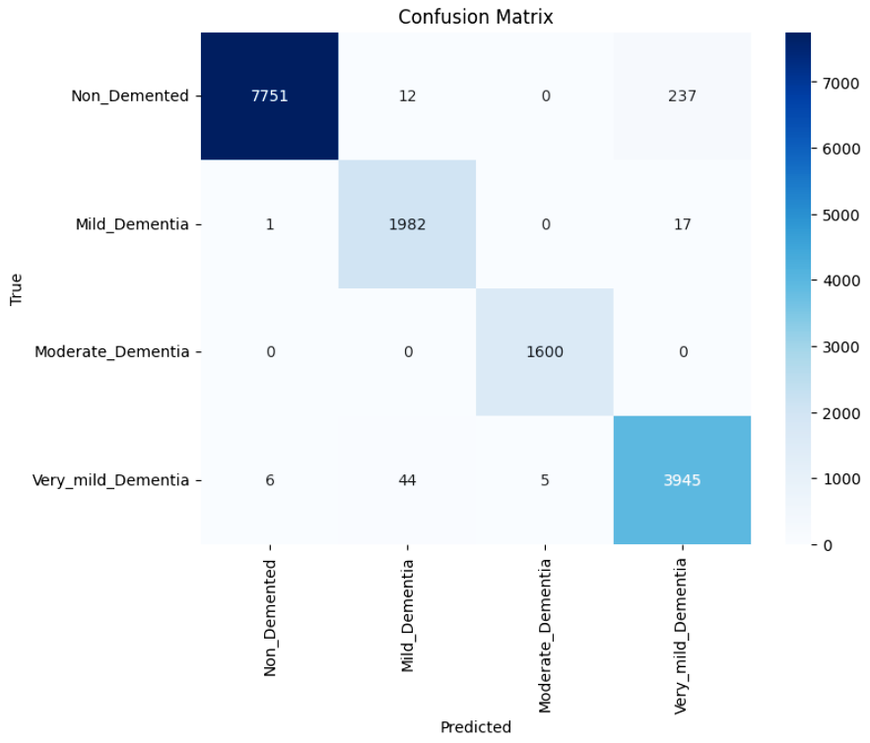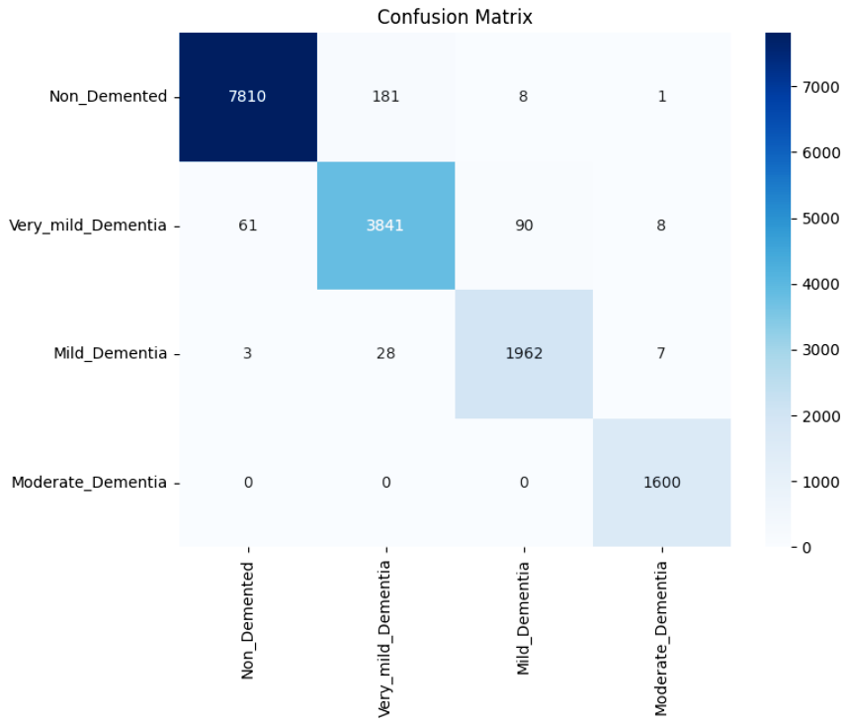
Fig 6.(a)Heatmap of Custom CNN;(b)Heatmap of VGG16.

Fig.6(a) shows confusion matrices for the custom CNN and Fig.6(b) for the VGG16 model, detailing their performance across the four dementia categories. Each row represents the true class and each column represents the predicted class, with cell values indicating the number of samples. The strong diagonal lines in both matrices reflect a high rate of correct predictions, especially for the non-demented and very mild demented classes.Off-diaogonal cells and sparsely populated,signifying few classifications and demonstrating the model’s ability to distinguish between patient groups with high accuracy.

5. Conclusion

In terms of predicting the various stages of AD, MRI brain images can be classified with excellent accuracy by advanced convolutional neural networks, namely EfficientNet-B1 and DenseNet201. These models encapsulate the non-obvious and minute changes in brain structure as the disease progresses. In this study, optimized architectures such as EfficientNet-B1 and DenseNet201 outperformed simpler and baseline CNN models, and could provide more reliable and stable diagnostic performance, which makes this technique’s clinical utility. Although there are still some hurdles with understanding the decision-making process of the models and applying them more broadly, the results demonstrate that early and accurate identification of Alzheimer’s will result in better quality care and medical outcomes.

Funding: This research did not receive any specific grant from funding agencies in the public, commercial, or not-for-profit sectors.

Dataset:The dataset was sourced from the Kaggle online platform which is available on https://www.kaggle.com/datasets/ninadaithal/imagesoasis/data

References

[1] Y. Chen et al. Automated Alzheimer's Disease Classification Using Deep Learning. ScienceDirect, 2024. https://www.sciencedirect.com/science/article/pii/S1687850723002601.
[2] E.R. Vinukonda et al. An Integrated Deep Learning Model for Early and Multi-Class Alzheimer's Disease Diagnosis. Nature, 2025.https://www.nature.com/articles/s41598-025-01845-y
[3]A.D. Arya et al. A systematic review on machine learning and deep learning approaches for Alzheimer's disease diagnosis using MRI and PET. Springer, 2023. https://link.springer.com/article/10.1186/s40708-023-00195-7
[4]Shaji et al., Helaly et al. Novel Deep Learning for Multi-Class Classification of Alzheimer's Dementia Stages. Frontiers in Bioinformatics, 2021- 2022. https://www.frontiersin.org/journals/bioinformatics/articles/10.3389/fbinf.2025.1567219/abstract
[5] S.E. Sorour et al. Classification of Alzheimer's Disease Using MRI Data Based on Deep Learning. ScienceDirect, 2024.https://www.sciencedirect.com/science/article/pii/S1319157824000296
[6] Fundación Dialneti et al. Advancements in Alzheimer's Disease Classification: Integrating Machine Learning, Neuroimaging, and Biomarkers. Dialnet, 2024. https://dialnet.unirioja.es/servlet/articulo?codigo=9968874
[7] S. Pan, S. Wang, X. Jin, S. Lu, et al. Enhancing Alzheimer’s Disease Diagnosis and Staging: A Multistage Deep Learning Framework Using Brain MRI. Springer, 2024. https://link.springer.com/article/10.1007/s12021-023-09625-7
[8] R. Turrisi et al. Deep learning-based Alzheimer's disease detection. Springer, 2024.https://link.springer.com/chapter/10.1007/978-981-15- 5546-6_50
[9] A.M. El-Assy et al. A novel CNN architecture for accurate early detection and classification of Alzheimer’s disease. Nature, 2024.https://www.nature.com/articles/s41598-024-53733-6
[10] B.S. Rao et al. Alzheimer's Disease Through Analysis of MRI Images Using Deep Learning. IEEE Xplore, 2023.https://ieeexplore.ieee.org/abstract/document/10182253/

